Publish Date: 22nd January 2026

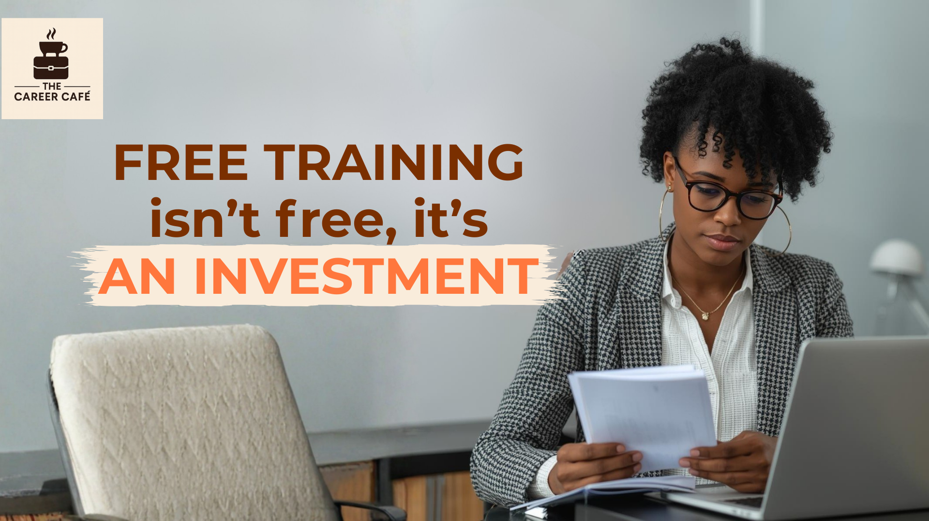

Free Career Training Is a Strategic Investment, Not Charity
A few months ago, we interacted with a mid-career professional who had quietly stopped applying for new roles.
Not because they lacked ambition or experience, but because every job description seemed to be asking for skills they were ‘supposed’ to already have.
They were good at their job. Trusted. Reliable. Experienced. But the market had moved, and their skills had not.
When a free training programme opened up in their field, they often hesitated, saying, “It feels like it’s not meant for someone at my level.”
That hesitation is more common than we admit - and it reveals a deeper misunderstanding about training itself.

Is Free training charity? No!
In many professional contexts, especially across Africa, free career training is treated with quiet suspicion.
- If it’s free, it must be remedial.
- If it’s free, it must be for beginners.
- If it’s free, it must lack seriousness.
- If it’s free, there’s a catch; nothing is free!
This assumption is not only incorrect but is strategically dangerous.
Training is not a reward for incompetence. It is the foundation upon which sustained competence is built.
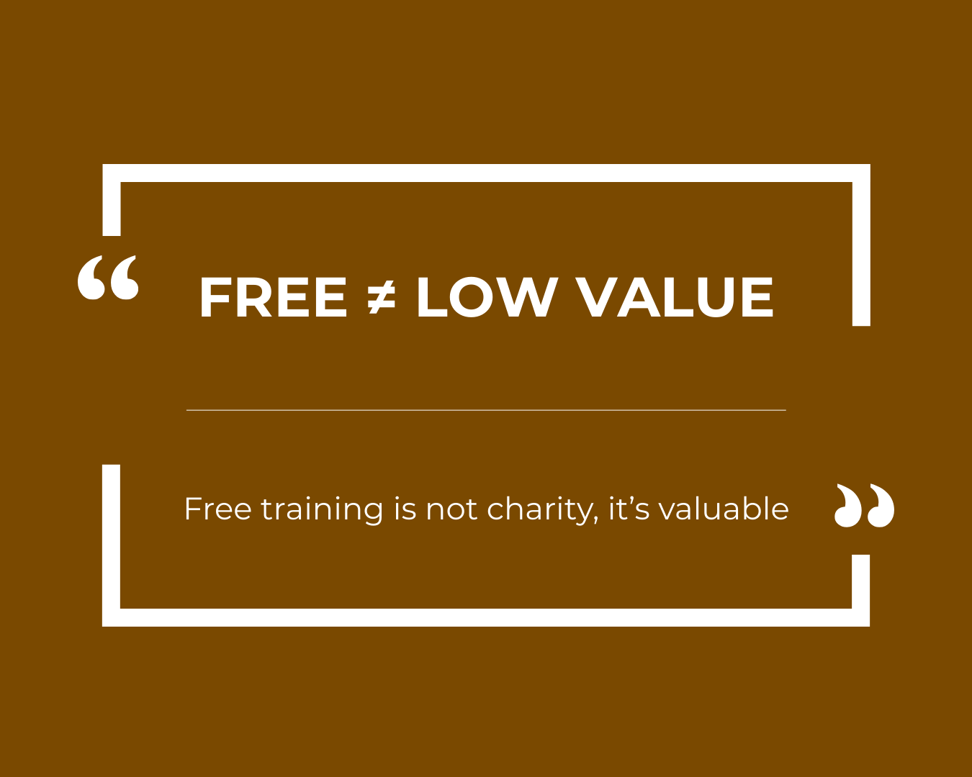

Training is education for your occupation
We often don’t train for the things we believe we are already good at.
Communication.
Leadership.
Analytical thinking.
Decision-making.
We rely on experience to carry us forward, assuming repetition alone will lead to mastery. But experience without training plateaus quickly. Growth requires structure, feedback, and updated context.
Training is not a chore.
It is education for your occupation.
Just as formal education prepares us to enter the workforce, continuous training is what allows us to remain relevant inside it.
It is a necessity, not an addition. And it is one of the few professional investments that can deliver an immediate return - better performance, clearer thinking and stronger positioning.

The global shift institutions are already responding to
The World Economic Forum estimates that over one billion people globally will need to upskill by 2030 to keep pace with a rapidly evolving labour market. (Source: Africa Leadership Magazine)
Automation and artificial intelligence are not just changing how work is done - they are reshaping which skills hold value. Demand is growing in areas such as technology, healthcare, renewable energy, data, and cybersecurity, while traditional education systems struggle to update curricula fast enough.
This growing mismatch between graduate skills and employer needs has forced a shift.
Today, corporations and institutions are no longer waiting for education systems to catch up. They are investing directly in training as a long-term workforce strategy.

Why leading companies invest in free training
You may have come across free training by tech giants such as Google and Microsoft, who have launched large-scale initiatives like Google Career Certificates and Microsoft’s Skills for the Future. This is not by accident!
These programmes offer free or subsidised training in high-demand fields such as data analytics, cloud computing and cybersecurity. This is often in partnership with local institutions and online platforms. Many remaining are accessible across various African tech hubs.
It’s not only global technology giants responding to this shift. Closer to home - often even within our own countries - free and subsidised career training is becoming part of the workforce strategy across Africa.
Organisations such as ALX are offering fully funded or low-cost online programmes in areas like software engineering, data, leadership, and professional skills.
Local universities, technical institutes, and public–private partnerships are also increasingly introducing short courses, bootcamps, and digital certifications designed to close real skills gaps.
This is not philanthropy. It is strategic talent development.
These organisations understand something critical:
- future competitiveness depends on a skilled, adaptable workforce - not just today’s hires, but tomorrow’s leaders.
Free training, in this context, is not generosity. It is foresight.

The real value of free career training
For professionals, the value of free training is not simply access. It is leverage.
It allows individuals to:
- Update skills before they become obsolete
- Close gaps without taking on financial risk
- Test new career directions with lower downside
- Strengthen credibility in changing markets
For institutions and partners, it creates:
- Stronger talent pipelines
- Faster onboarding and upskilling
- Reduced skills mismatch
- Greater workforce resilience
When designed well, free training shifts entire systems, not just individual careers.
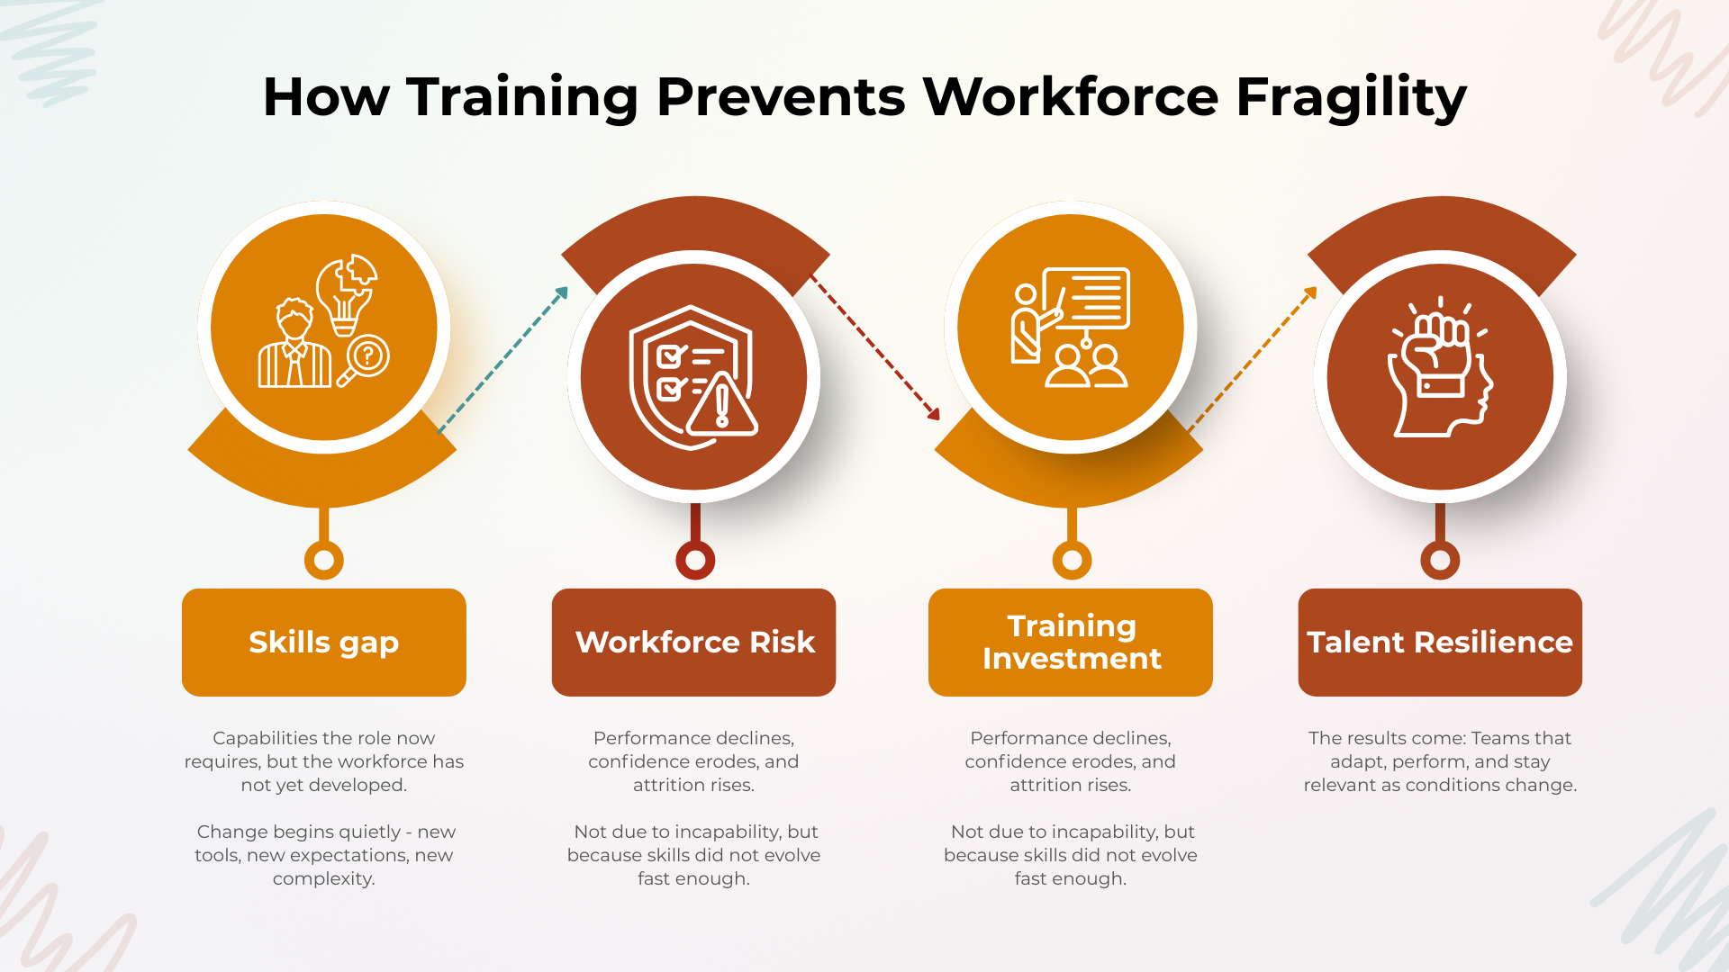

Growth has a predictable formula
If growth is what you seek, training is how you will find it.
Not inspiration.
Not motivation.
Not pressure.
Training!
It sharpens what you already know.
It exposes blind spots that experience can hide.
It creates language for skills you’ve been using informally.
Most importantly, it turns potential into capability. This is true in careers and in life. We rarely improve significantly at anything we refuse to practise deliberately.

Reframing how we view opportunity
Free career training should not be approached with embarrassment or suspicion.
It should be approached with a strategy.
The professionals who benefit most from career training are often not beginners. They are those who understand that relevance is built, not assumed. That competence must be renewed. That markets do not reward effort - only value.
At The Career Café, we see training as infrastructure. Not charity. Not remediation. Not a favour.
Infrastructure for careers that must operate in complex, fast-changing systems.
And infrastructure is always an investment.
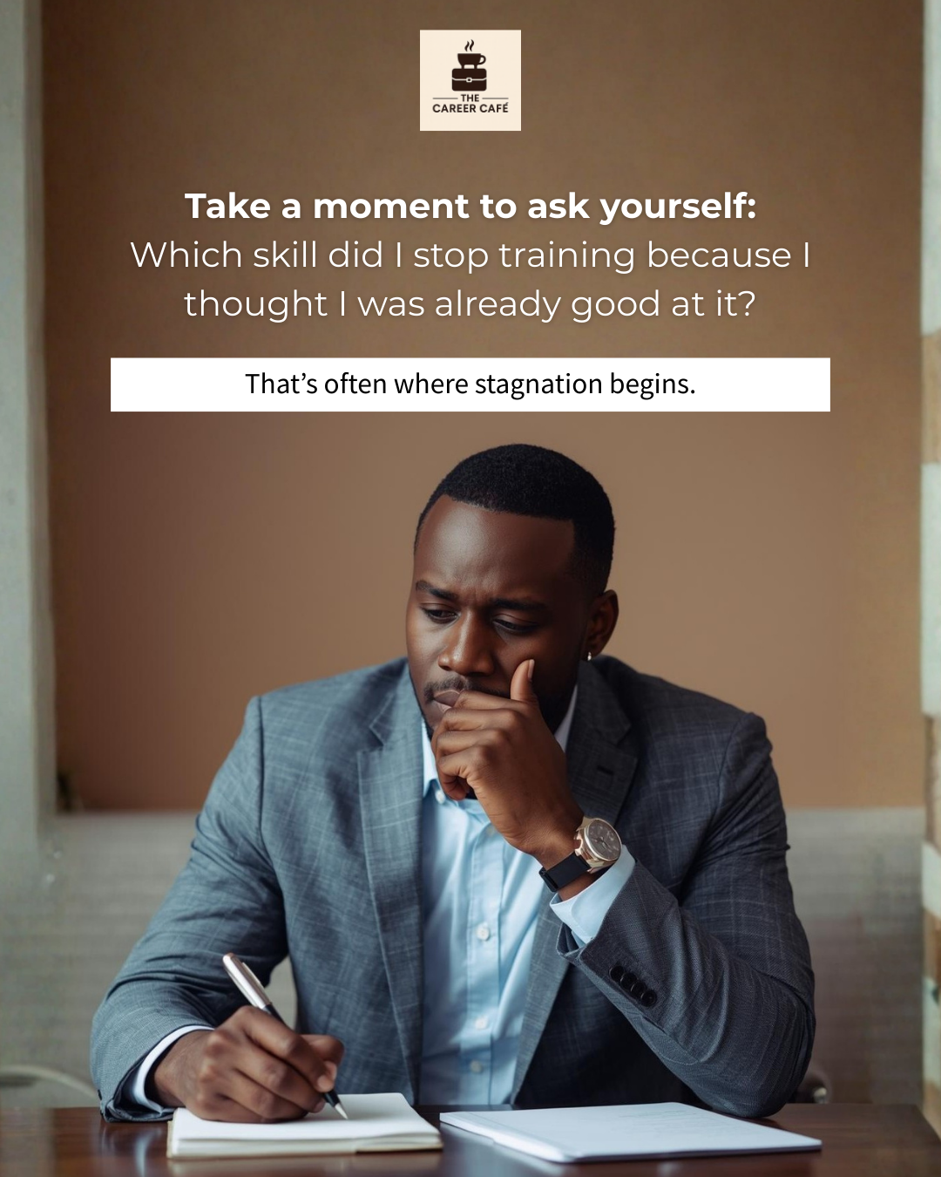

If your industry is shifting faster than your skills, that gap will not close on its own.
Training is one of the few levers you can pull immediately - without waiting for permission, promotion, or crisis.
So, if there’s been a course, diploma, or webinar you have been thinking about, take it! Sign up today.

Caption:
Have you ever signed up for a free course or training programme and never started?
Or started… and quietly didn’t finish?
Because it was free, it felt like nothing was lost, right? Fair enough.
But what often goes unnoticed is what could have been gained.
That assumption - that free career training is optional or expendable - is costing professionals and institutions far more than they realise.
In this week’s article, we challenge the idea that free training can be overlooked or treated as unimportant. If the most competitive organisations in the world are investing heavily in free and subsidised training, it’s worth asking WHY.
This piece explores why training is not an extra, but infrastructure - and why free career training is one of the most strategic investments available as work continues to change.

